

The EyeNalysis User’s Manual

Document Revision 3.00.00

TABLE OF CONTENTS

Introduction 5
System Requirements 5
Getting Started 5
Generating Reports (Data Mining) 5
1. Open log file 5
2. Initializing data 6
3. Quick overview 7
4. EyeNalysis Main – Data Mining Query Interface. 8
4-1.Who 8
4-2.When 10
4-3.Where 12
4-4.What 13
4-5. Report 14
5. Processing data 15
6. EyeNalysis Reports 16
Printing reports 18
Auto Scheduled Reports 19
LICENSE AGREEMENT 24

© 2000-2001 BAJAI Inc.
Information in this documentation is subject to change without notice by BAJAI Inc.
The contents of all material available in this document are copyrighted by BAJAI Inc. unless otherwise indicated. All rights are reserved by BAJAI Inc., and content may not be reproduced, disseminated, published, or transferred in any form or by any means, except with the prior written permission of BAJAI Inc. Copyright infringement is a violation of federal law, subject to criminal and civil penalties.
Legal Notice and Disclaimer:
BAJAI Inc. “including its employees and agents” assume no responsibility for any consequences resulting from the use of the information herein, or in any respect for the content of such information, including “but not limited to” errors or omission, the accuracy or reasonableness of factual or scientific assumptions, studies and/or conclusions, the defamatory nature of statements, ownership of copyright or other intellectual property rights and the violation of property, privacy or personal rights of others. BAJAI Inc. is not responsible for, and expressly disclaims all liability for, damages of any kind arising out of use, reference to or reliance on such information. No guarantees or warranties, including “but not limited to” any express or implied guarantees, warranties of merchantability or fitness for any particular use or purpose, are made by BAJAI Inc. with respect to such information.
Third Parties:
Reference herein to any specific commercial products, process, or service by trade name, trademark, manufacturer, or otherwise, does not constitute or imply its endorsement, recommendation, or favoring by BAJAI Inc. and such reference shall not be used for advertising or product endorsement purposes. Any or all websites used for example references only and may have trademarks or copyrights and should be considered as proprietary.
Trademarks:
BAJAI, the BAJAI logo, Iajabot, ProxEye, BajEye, EyeNalysis, EyeUpdate, EyeMail, OCULAR and “images, everything” are registered trademarks, slogans or trademarks of BAJAI Inc.
BAJAI Inc. may have patents or pending patent applications, trademarks, copyrights, or other intellectual property rights covering subject matter in this document. The furnishing of this document does not give any license to these patents, trademarks, copyrights, or other intellectual property rights except as a expressly provided in any written license agreement from BAJAI Inc.

Introduction

BAJAI’s EyeNalysis is a user-friendly management tool that is perfect for evaluating and reporting employee’s Internet web use. The tool comes as part of the ProxEye package and is installed when you install ProxEye.

System Requirements

To use EyeNalysis, your system should have:
- An IBM compatible PC with 133 MHZ or higher processor recommended
- Operating System that supports the Java Runtime Environment.
- 64 MB of RAM
- 20 MB of free hard disk space
- VGA, Super VGA, or better display adapter at 1024 X 768 pixels resolution
- Printer, color recommended.
8. Installation of JRE 1.3 or higher (JAVA Runtime Environment)

Getting Started
To begin, you can start the EyeNalysis tool by finding the shortcut in the Start Menu, in the ProxEye area. You can find this shortcut here:

START→PROGRAMS→BAJAI→PROXEYE→EYENALYSIS

The icon for EyeNalysis: 

Generating Reports (Data Mining)
This section will walk you through, step by step, the process of generating a report of Web usage. Each step contains screen shots and an explanation of the requirements for each stage in the process.

1. Open log file

Whenever you start EyeNalysis, open log file dialog box appears (Fig 1-1), asking you to select a log file. (Check your “proxeye.conf” file to get the name of log file. In this manual, we will use the name of log file as “proxeye.log”).

Note: It is important to ensure that you have selected the correct log file.
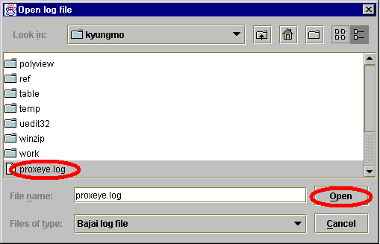

<1-1.Open log file dialog>

2. Initializing data

When you open the log file, EyeNalysis automatically initializes the data from the user selected log file. This process may take a few minutes depending on your system and the size of log file.


< 2-1 Initializing >

3. Quick overview

The “quick overview” of EyeNalysis reports all historical data in log file. This includes a report that is summarizing all Internet activities of all employees represented by all IP addresses at your company. Clicking a header of each column of the table will sort its column by ascending or descending order (See figures 3-1 and 3-2). The table is initially sorted by IP address in ascending order. Press ‘OK’ button to continue, ‘CANCEL’ button to quit, and ‘PRINT’ button to print the table.

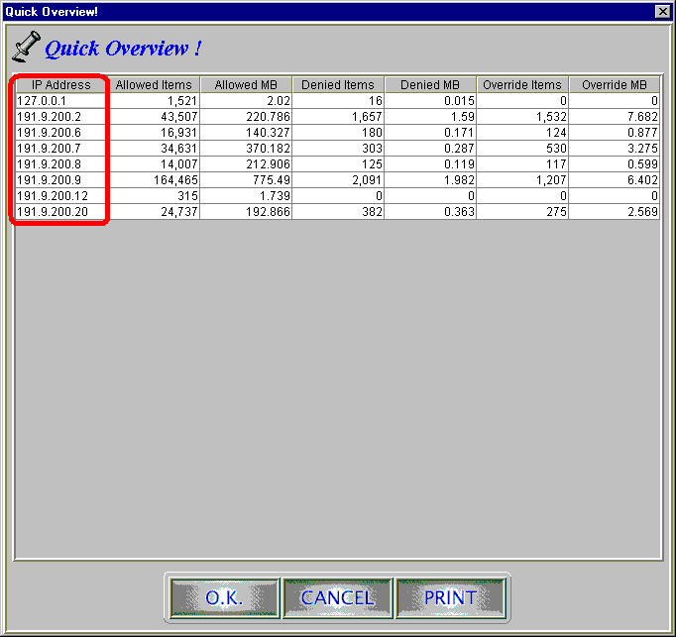

<3-1. Quick overview>

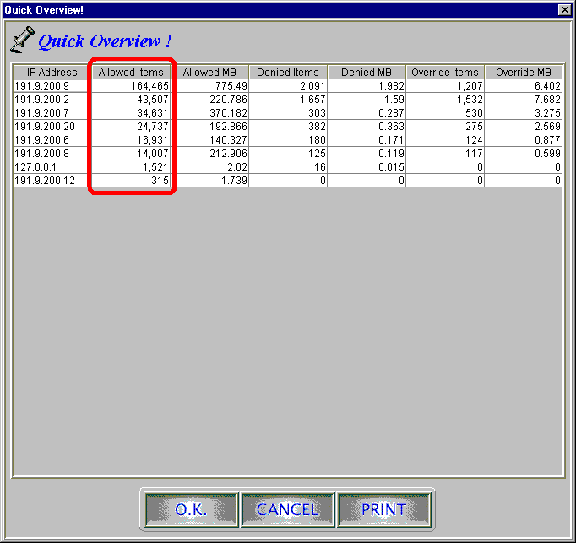

<3-2.Table sorted by second column>

4. EyeNalysis Main – Data Mining Query Interface.

With this interface, you can easily look for specific information you want. Using 4 basic categories (who, when, where and what) will help you to accomplish your search from the stored data. It is important that you go through the four query categories in order, starting with who, continuing through whe, where, and then what. There is a help window in the lower right corner of the window (see fig 4-1) to aid you through the process.

4-1.Who

Who is the source of information you want? You can specify each individual IP address for your searching. You can also group Top number of IP addresses or all of IP addresses at your company. Top number of IP addresses can vary depends on your choice of next following 3 categories. See figures 4-1, 4-2 and 4-3.

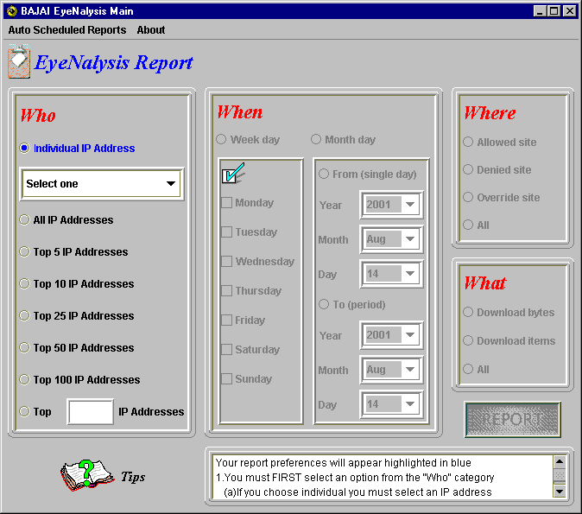

< 4-1. Who Category >

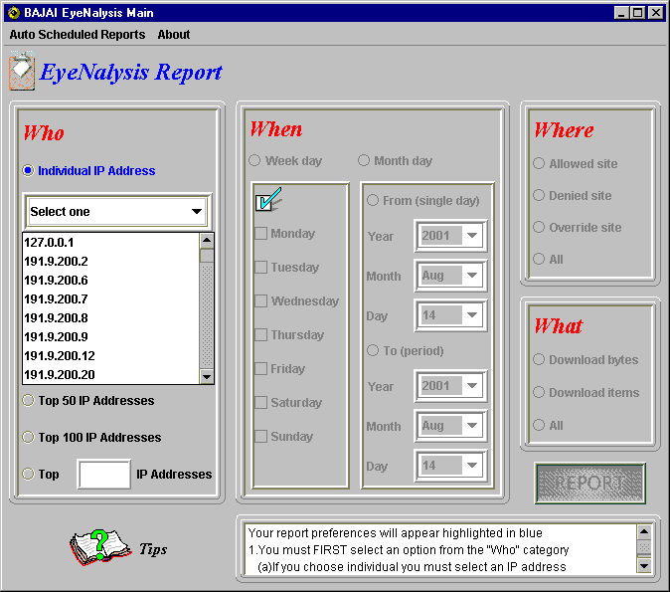

< 4-2. Individual selection >

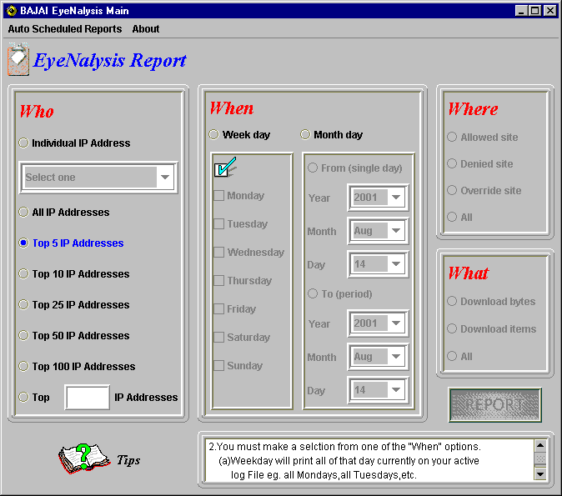

< 4-3. Top N selection >

4-2.When
Which time period do you want to check? Since you are keep tracking the past Internet use of your employee defined in who category. If you are using an historical log file, obviously date ranges are applicable to the time span the log was generated. Since your employee’s working hours may vary such as full or part time, shift work etc, you may select weekday search rather than doing fixed month-day search (figure 4-5). However, you may want to report regular business period such as yearly, quarterly, monthly, biweekly, weekly and daily. In this case, Month-day search is better solution for your regular report.

EyeNalysis interprets a selection of ‘from’ button as single day search and a selection of ‘To’ button as time interval that is between the day at ‘from’ box and the day at ‘To’ box.. See figure 4-5 and 4-6. When specifying a date range, the range must obey the natural laws of Physics, and the From date must be earlier than the To date. Should you decide to try to violate the fundamental laws of physics, EyeNalysis will not allow you to continue until time is back in order.

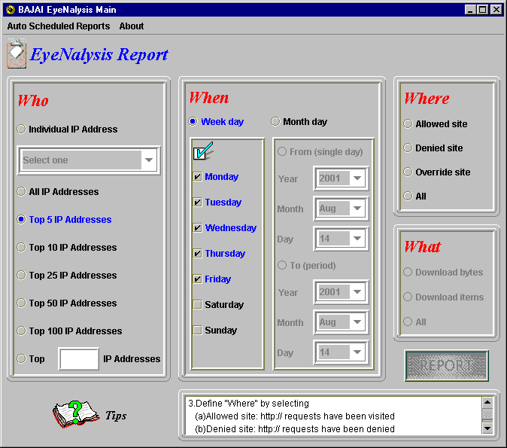

< 4-4. When Category >

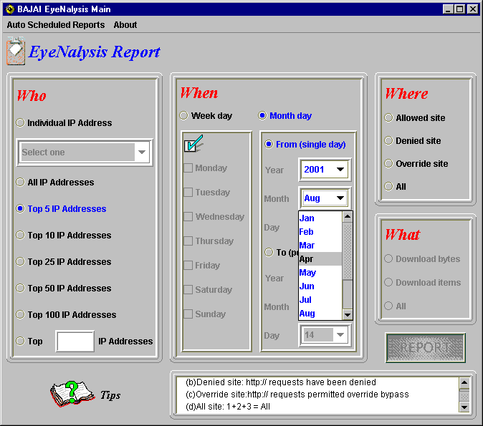

< 4-5. Month selection of Single day >

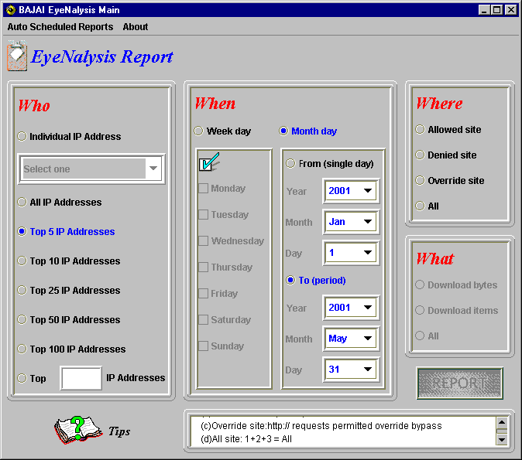

< 4-6. Interval time – From Jan 1, 2001 To Mar 31, 2001 >

4-3.Where
The where category (fig 4-7) allows you specify the reporting activity of allowed, denied and override accesses. BAJAI classification lists categorize web sites on the Internet, while your system administrators define blocked or allowed sites. The level of accessibility to the site is defined by your company’s Internet policy and the configuration of ProxEye. If this is unclear, please consult your system administrators or the ProxEye manual for details.

- Allowed site: HTTP request is allowed.
- Denied site: HTTP request is denied.
- Override site: HTTP request overridden after the first denied request, and subsequent requests to that domain from that person.

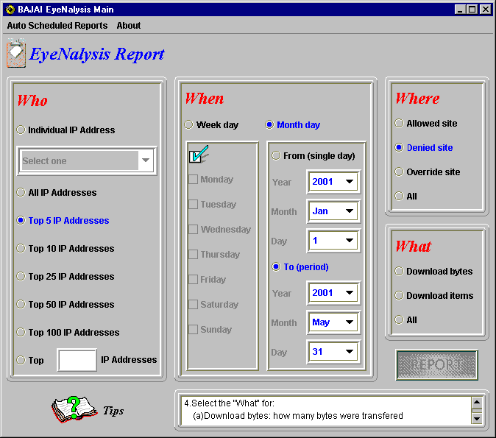

<4-7.Where Category>

4-4.What
You may evaluate your employee’s Internet use in terms of Download Bytes or Items.

Download Bytes represents how many bytes have been transferred from the sites your employee had visited during their Internet use.

Download Items represents how many items have been transferred from the web sites during your employee’s Internet use.

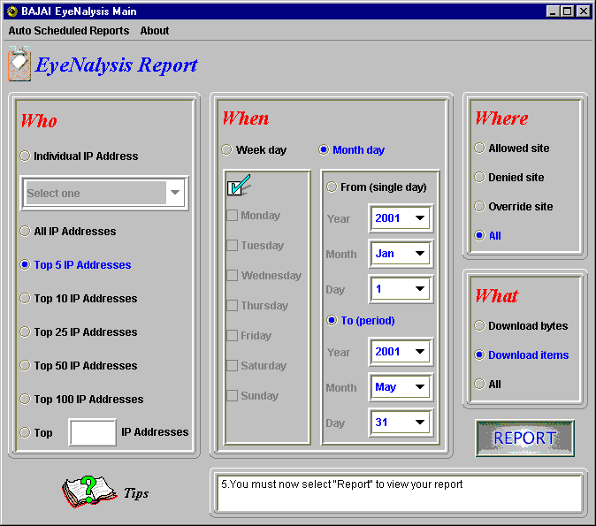

<4-8.What Category>

4-5. Report

Before moving to next step, you should check your selections again and make sure the search criteria you specified are representing the purpose of your search. For example, for the settings in figure 4-8, my goal is to report on the top 5 various IP addresses for the 3 possible combinations such as:
- allowed site with download items
- denied site with download items
- override site with download items

during working days from Jan 01, 2001 until May 31, 2001.
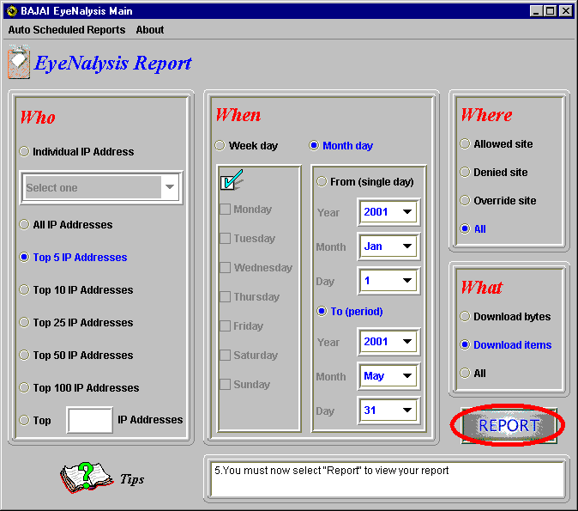

<4-9. Report >

5. Processing data
When you press the ‘report’ button, EyeNalysis begins automatically processing the data with given search criteria. This process will take few seconds to a few minutes depending on your system speed 1and the size of log file. A progress bar will indicate how much of the request is processed.

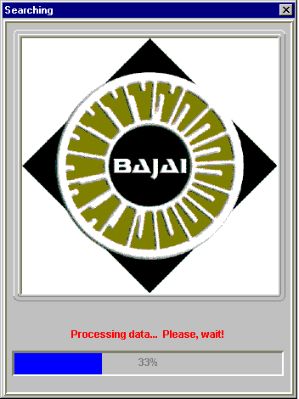

<5-1. Processing >

6. EyeNalysis Reports

After processing the data, EyeNalysis will generate several reports that detail the information you specified in the query interface. In general, a graph comes first and the associated table for the graph will follow. See figures 6-1 to 6-4.

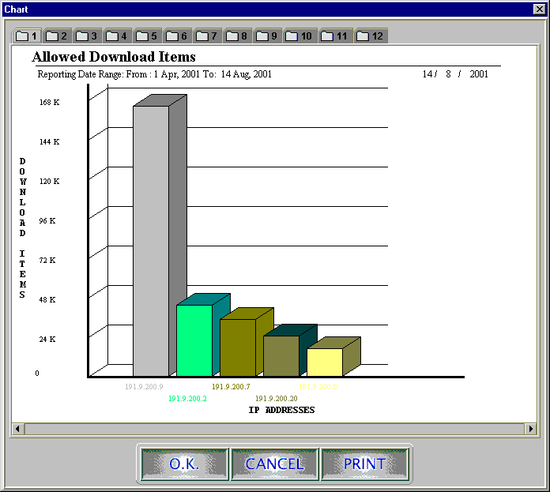
<6-1. Bar chart for allowed download items>

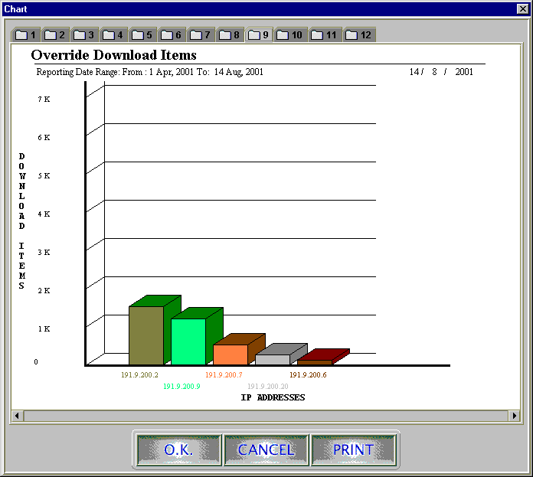
<6-2. Bar chart for override download items >

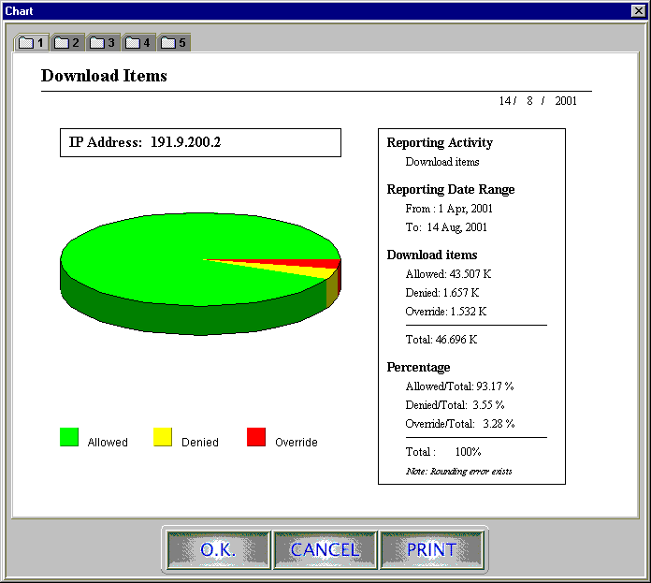
<6-3. Pie chart for download items >

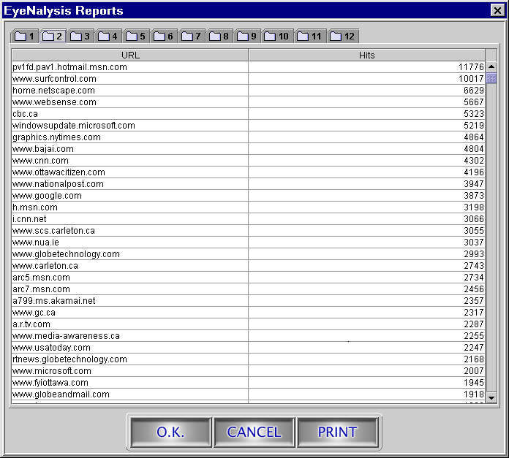
<6-4.Visited Site list (Allowed) >

Printing reports

You can see the ‘PRINT’ button at the right bottom of the window. When you press the print button, the following page setup dialog box will open. Since there are different printing facilities from the user to user, we highly recommend the size of paper should be letter 8 ½ * 11 inches and orientation of page should be landscape.

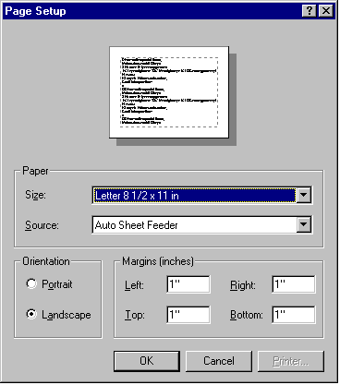
<7-1.Page dialog (Windows NT4.0) >

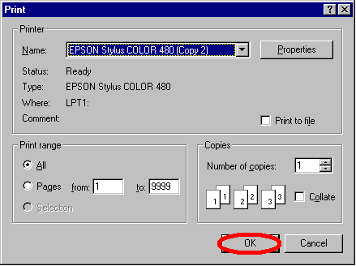

<7-2.Pint dialog (Windows NT4.0) >

Auto Scheduled Reports

You may want EyeNalysis to generate a report on a regular basis, even though you are not present in the office. To satisfy this need, EyeNalysis allows auto-scheduled tasks. Moreover, EyeNalysis supports multiple scheduled generation of reports at any time you want, so you can set up at most 15 scheduled reports with few mouse clicks. The following illustrates how typical use of auto scheduled task such as Top 10 Daily report, Top 50 Weekly report, Top 100 Monthly report is configured.

To get the reports, configuration of both EyeNalysis and your O.S (operating system) is required. In Linux or other UNIX variants, a cron job will need to be set up (see the man pages for more information about cron). In Windows, you will need to use the task scheduler.

Illustrate 8-1 to 8-3 explains how to set up your auto scheduled tasks for EyeNalysis and 8-4 to 8-6 displays the configuration of a Scheduled Task on Windows NT 4.0 (For more details, check your Windows Manual or OS Manual).

As shown in figure 8-4, there are three brand-new batch files, T10DR.bat, T50WR.bat, and T100MR.bat in the EyeNalysis folder. Each of batch files has a different set of reporting criteria, so you will require 3 scheduled tasks on your OS.

For example, T100MR.bat is a criteria file for Top 100 Monthly Report. You must go through the process as shown in figures 8-5, and 8-6 to set up T100MR.bat file. At the first day of every month (exactly 2 A.M), EyeNalysis will automatically generate Top 100 Monthly Report. Same configuration processes are required for the other

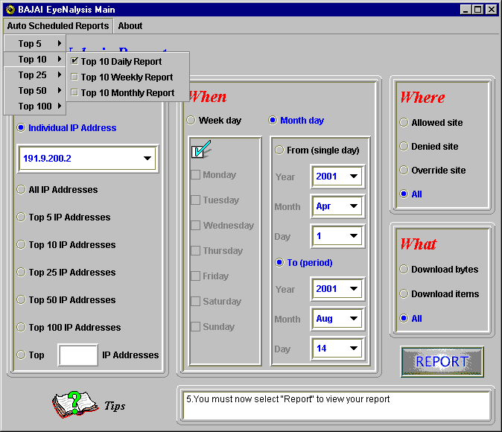
<8-1. Top 10 Daily Report >

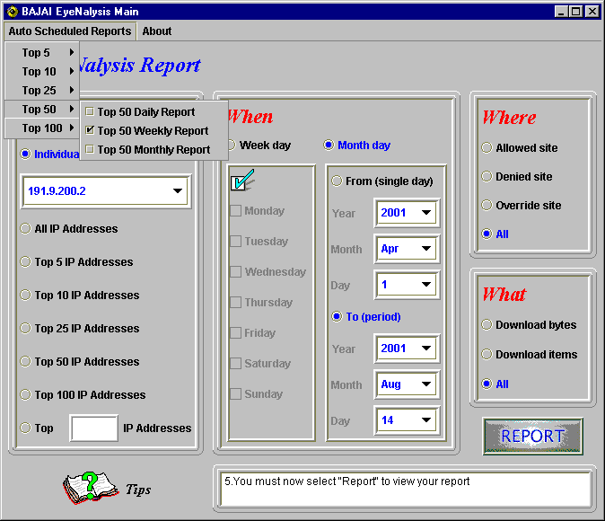
< 8-2. Top 50 Weekly Report >

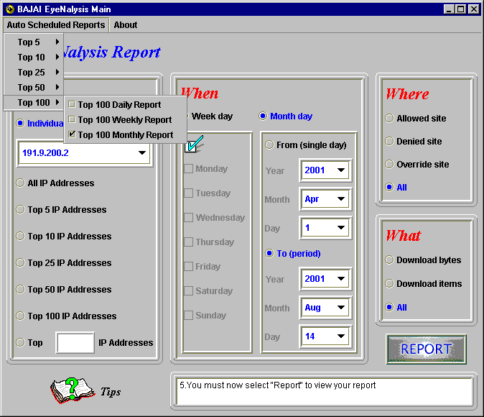

<8-3. Top 100 Monthly Report >

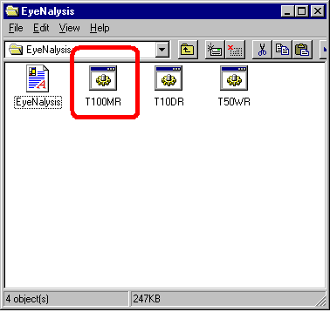
<8-4.Mutiple Scheduled Reports (Windows NT4.0) >

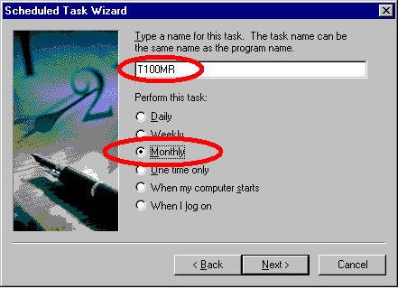

<8-5. Setting Top 100 Monthly Report (T100MR.bat) (Windows NT4.0) >

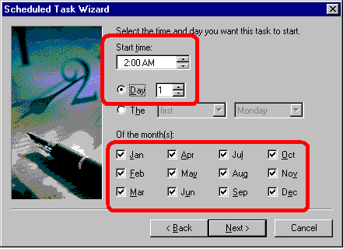

<8-6. Setting Monthly Report (Windows NT4.0) >

The table below is a list of criteria files created by EyeNalysis and a description of the report that it generates.

File Name | Description
T5DR.bat | A Daily report of Top 5 IP addresses with all Internet sites and activities
T5WR.bat | A Weekly report of Top 5 IP addresses with all Internet sites and activities
T5MR.bat | A Monthly report of Top 5 IP addresses with all Internet sites and activities
T10DR.bat | A Daily report of Top 10 IP addresses with all Internet sites and activities
T10WR.bat | A Weekly report of Top 10 IP addresses with all Internet sites and activities
T10MR.bat | A Monthly report of Top 10 IP addresses with all Internet sites and activities
T25DR.bat | A Daily report of Top 25 IP addresses with all Internet sites and activities
T25WR.bat | A Weekly report of Top 25 IP addresses with all Internet sites and activities
T25MR.bat | A Monthly report of Top 25 IP addresses with all Internet sites and activities
T50DR.bat | A Daily report of Top 50 IP addresses with all Internet sites and activities
T50WR.bat | A Weekly report of Top 50 IP addresses with all Internet sites and activities
T50MR.bat | A Monthly report of Top 50 IP addresses with all Internet sites and activities
T100DR.bat | A Daily report of Top 100 IP addresses with all Internet sites and activities
T100WR.bat | A Weekly report of Top 100 IP addresses with all Internet sites and activities
T100MR.bat | A Monthly report of Top 100 IP addresses with all Internet sites and activities

LICENSE AGREEMENT

I. License and Use

Subject to the following terms and conditions, we grant you a royalty-free, nontransferable and nonexclusive right:

- to use this version of EYENALYSIS on any single networked computer for which licensed seat users can access, provided that EYENALYSIS is (1) used on only one such computer at any one time, and (2) used only by the licensed seat users; and

- to make and distribute to others unmodified copies of the demonstration version of EYENALYSIS, without any direct or indirect charge (except for the cost of the media in which the demonstration version is fixed), for non-commercial uses only.

II. Limitation of Liability

ALL USE OF EYENALYSIS IS ENTIRELY AT YOUR OWN RISK. WE WILL NOT BE RESPONSIBLE TO YOU OR ANY THIRD PARTIES FOR ANY DIRECT, INDIRECT, CONSEQUENTIAL, SPECIAL OR PUNITIVE DAMAGES OR LOSSES YOU MAY INCUR IN CONNECTION WITH EYENALYSIS OR YOUR USE THEREOF, REGARDLESS OF THE TYPE OF CLAIM OR THE NATURE OF THE CAUSE OF ACTION.

III. Indemnity

You will defend and indemnify us against (and hold us harmless from) any claims, proceedings, damages, injuries, liabilities, losses, costs and expenses (including attorneys’ fees), relating to any acts by you in connection with EYENALYSIS, leading wholly or partly to claims against us by third parties, regardless of the type of claim or the nature of the cause of action.

IV. Disclaimer of Warranty

EYENALYSIS IS PROVIDED “AS IS”, WITH ALL FAULTS. WE MAKE NO WARRANTIES, EXPRESS OR IMPLIED, AS TO MERCHANTABILITY, FITNESS FOR A PARTICULAR USE OR PURPOSE, TITLE, NON-INFRINGEMENT, OR ANY OTHER CONDITION OF EYENALYSIS.

V. Proprietary Rights

Except as specifically licensed above, you may not copy, modify, adapt, merge, include in other software, reproduce, translate, distribute, reverse engineer, decompile or disassemble any portion of EYENALYSIS.

VI. Miscellaneous

This Agreement contains the entire understanding between you and us relating to your use of EYENALYSIS and supersedes any prior statements or representations. This Agreement can only be amended by a written agreement signed by you and us. This Agreement shall be interpreted and enforced under the laws of the province of Ontario, Canada.

BY INSTALLING EYENALYSIS, YOU ARE EXPLICITLY AGREEING TO THE TERMS AND CONDITIONS SET WITHIN.

